Matrix metalloproteinase-2 and inflammatory indices as discriminatory biomarkers for coronary artery ectasia versus stenosis: A cross-sectional study
Jalil NI¹, Al-Timimi RJ², Al-Rubaye AS¹

¹Department of Chemistry and Biochemistry, College of Medicine, Al-Nahrain University, Baghdad, Iraq
²Department of Medicine, College of Medicine, Al-Nahrain University, Baghdad, Iraq

Submitted: 14th January 2026
Accepted: 16th May 2026
Published: 31st October 2026
ID: Orcid ID
Abstract
Objective: To evaluate serum matrix metalloproteinase-2 (MMP-2), neutrophil-to-lymphocyte ratio (NLR), platelet-to-lymphocyte ratio (PLR), red cell distribution width (RDW), and lipid profiles for discriminating coronary artery ectasia (CAE) from coronary artery stenosis (CAS) and healthy controls.
Methods: This cross-sectional study enrolled 120 participants (40 with angiographically confirmed CAE, 40 with CAS, and 40 healthy controls) between November 2024 and March 2025. Serum MMP-2 was measured using an enzyme-linked immunosorbent assay. Lipid profiles and complete blood counts were determined using automated analysers. Group comparisons employed Kruskal–Wallis H tests with Bonferroni correction. Receiver operating characteristic (ROC) curve analysis assessed diagnostic performance.
Results: MMP-2 levels were significantly elevated in CAE (73.48 ± 7.65 ng/mL) compared to CAS (38.49 ± 4.40 ng/mL) and controls (15.01 ± 4.70 ng/mL) (p < 0.001 for all pairwise comparisons). ROC analysis demonstrated excellent discrimination (area under the curve = 1.000) for distinguishing CAE from both CAS and controls, though this finding requires validation in larger cohorts. The CAE group exhibited the most severe atherogenic dyslipidaemia, with the highest total cholesterol, triglycerides, and lowest high-density lipoprotein cholesterol. Inflammatory indices (NLR, PLR, RDW) were significantly higher in CAE than in CAS and controls (p < 0.001), indicating a pronounced neutrophil-dominant inflammatory milieu in ectatic disease.
Conclusion: Marked MMP-2 elevation combined with severe dyslipidaemia and amplified inflammatory indices distinguishes CAE from CAS, suggesting that excessive proteolytic and inflammatory pathways drive pathological vascular dilation in coronary artery ectasia.

Keywords: Coronary Artery Disease, Coronary Aneurysm, Matrix Metalloproteinase 2, Inflammation, Dyslipidaemias

Plain English Summary
This study examined whether specific blood markers can help doctors distinguish between two different forms of coronary artery disease: ectasia, where the arteries become abnormally widened, and stenosis, where they become narrowed by plaque buildup. The researchers measured an enzyme called MMP-2 (which breaks down the structural proteins of blood vessel walls), several markers of inflammation (including the ratio of neutrophils to lymphocytes, platelets to lymphocytes, and red cell distribution width), and cholesterol levels in 120 people. Among these participants, 40 had coronary artery ectasia, 40 had coronary artery stenosis, and 40 were healthy volunteers. The results showed that people with ectasia had MMP-2 levels nearly five times higher than healthy individuals and roughly twice as high as those with stenosis. Patients with ectasia also had worse cholesterol profiles and higher inflammation markers compared to both stenosis patients and healthy controls. These findings suggest that different biological mechanisms drive artery widening versus narrowing, and that measuring MMP-2 and inflammation markers could help doctors better identify which type of artery disease a patient has. However, because this study was relatively small, larger studies are needed to confirm these results before they can be used in routine clinical practice.

Introduction
Coronary artery disease (CAD) remains the leading cause of morbidity and mortality worldwide, accounting for a substantial proportion of cardiovascular-related deaths despite remarkable advances in diagnostic and therapeutic strategies (1, 2, 3, 4). Conversely, coronary artery ectasia (CAE), defined as abnormal localised or diffuse dilation of the coronary arteries exceeding 1.5 times the normal diameter, represents a distinct yet clinically significant phenotype associated with adverse cardiovascular outcomes, including thrombosis, distal embolisation, and acute coronary syndromes (5). Understanding the pathophysiological differences between CAE and typical stenotic atherosclerosis is essential for improving risk stratification and guiding personalised management.
The structural and functional integrity of the coronary vasculature is tightly regulated by endothelial homeostasis, inflammatory balance, extracellular matrix (ECM) turnover, and vascular smooth muscle cell activity (6). Disruption of these regulatory mechanisms results in maladaptive vascular remodelling, which underlies both coronary artery stenosis and ectasia. Recent evidence highlights the pivotal role of inflammatory mediators, matrix-degrading enzymes, and fibrotic biomarkers in driving coronary artery pathology, emphasising the importance of integrated biomarker profiling for improved risk stratification and mechanistic understanding of CAD phenotypes (7).
Matrix metalloproteinases (MMPs), particularly MMP-2, are zinc-dependent proteolytic enzymes that regulate ECM degradation and vascular remodelling. MMP-2 facilitates the breakdown of collagen and elastin fibres within the arterial wall, thereby contributing to plaque destabilisation and excessive vascular dilatation. Dysregulation of MMP-2 results in uncontrolled matrix degradation, promoting either progressive luminal narrowing in stenotic disease or pathological arterial dilation in ectatic segments. This enzyme has been increasingly recognised as a critical determinant of coronary artery remodelling patterns (8). In parallel, systemic inflammatory indices such as neutrophil-to-lymphocyte ratio (NLR) and platelet-to-lymphocyte ratio (PLR) have gained significant attention as readily available, cost-effective biomarkers reflecting immune-inflammatory activation. Elevated NLR and PLR values have demonstrated robust associations with the severity of coronary stenosis, plaque vulnerability, and adverse cardiovascular outcomes (9). These indices reflect the combined impact of innate immune activation, lymphocyte suppression, and platelet-driven thrombo-inflammatory processes, which are particularly prominent in acute coronary syndromes and complex coronary lesions (10).
Red cell distribution width (RDW), a haematological marker reflecting erythrocyte size heterogeneity, has recently emerged as a powerful prognostic indicator in cardiovascular disease. Increased RDW has been independently associated with endothelial dysfunction, oxidative stress, systemic inflammation, and poor clinical outcomes in CAD patients (11). RDW elevation appears to reflect chronic inflammatory and oxidative insults affecting erythropoiesis and red blood cell survival, thereby providing indirect insight into vascular disease burden and systemic metabolic stress (12). Furthermore, dyslipidaemia remains a cornerstone risk factor in the initiation and progression of coronary artery disease. Elevated levels of low-density lipoprotein cholesterol (LDL-C), triglycerides, and reduced high-density lipoprotein cholesterol (HDL-C) contribute directly to endothelial injury, foam cell formation, oxidative stress, and plaque development (13). In patients undergoing diagnostic coronary angiography, lipid abnormalities strongly correlate with both the severity of coronary stenosis and the presence of coronary ectasia, suggesting a shared lipid-driven inflammatory and remodelling pathway (14).
Recent publications have highlighted the growing burden of coronary artery disease in diverse populations and the need for region-specific biomarker studies (15). The present study was therefore designed to evaluate the discriminatory capacity of serum MMP-2, haematological inflammatory indices (NLR, PLR, RDW), and lipid profiles in differentiating coronary artery ectasia from coronary artery stenosis and healthy controls among patients undergoing diagnostic coronary angiography.

Materials and Methods
Study Design and Setting
This cross-sectional study was conducted at the Department of Chemistry and Biochemistry, College of Medicine, Al-Nahrain University, in collaboration with the Clinical Biochemistry Laboratory at Al-Imamain Al-Kadhimain Medical City, Ibn Al-Bitar Centre for Cardiac Surgery, and Baqubah Teaching Hospital. The study was carried out over a five-month period from November 2024 to March 2025.

Study Population
A total of 120 participants were recruited and equally divided into three groups of 40 each: patients with angiographically confirmed coronary artery ectasia (CAE), patients with angiographically confirmed coronary artery stenosis (CAS) without ectasia, and apparently healthy controls. All participants provided written informed consent before enrolment. Structured questionnaires were completed to collect demographic and clinical data, including age, sex, body mass index (BMI), smoking status, history of diabetes mellitus, and hypertension. Participants’ ages ranged from 35 to 65 years.

Clinical Classification
Group 1 (CAE group)
Forty patients (26 males, 14 females) with angiographically confirmed coronary artery ectasia, defined as localised or diffuse coronary artery dilation exceeding 1.5 times the diameter of an adjacent normal reference segment.

Group 2 (CAS group)
Forty patients (27 males, 13 females) with angiographically confirmed coronary artery stenosis, defined as luminal narrowing of ≥50% in at least one major epicardial coronary artery, without evidence of ectasia.

Control group
Forty healthy subjects (18 males, 22 females) with no history or clinical evidence of coronary artery disease, matched for age range but not for cardiovascular risk factors.

Inclusion and Exclusion Criteria
Inclusion criteria comprised adults aged 35–65 years undergoing coronary angiography for suspected ischaemic heart disease and diagnosed with either CAE or CAS, together with apparently healthy individuals aged 35–65 years without evidence of CAD for the control group.
Exclusion criteria included the presence of acute or chronic infection, autoimmune disease, malignancy, renal or hepatic impairment, recent surgery or trauma within the previous three months, presentation with acute coronary syndrome (including unstable angina, NSTEMI, or STEMI), and left ventricular systolic dysfunction defined as an ejection fraction below 40%.

Blood Sampling and Laboratory Analysis
Blood samples were collected from all participants following an overnight fast of at least 10 hours. Using sterile 10 mL disposable syringes via venipuncture, each sample was divided into two portions. Approximately 2 mL of whole blood was transferred into EDTA-containing tubes for complete blood count (CBC) analysis, from which NLR, PLR, and RDW were calculated. The remaining 7 mL of blood was placed into plain gel tubes to facilitate serum separation. Samples were allowed to clot at 37°C for 10–15 minutes and were then centrifuged at 3000 rpm for 10 minutes. The separated serum was carefully collected and divided into two aliquots.
One serum aliquot was used for lipid profile measurements, including total cholesterol (TC), triglycerides (TG), high-density lipoprotein cholesterol (HDL-C), low-density lipoprotein cholesterol (LDL-C), very low-density lipoprotein (VLDL), and non-HDL cholesterol. These parameters were determined using an automated chemistry analyser (Cobas c311, Roche Diagnostics, Germany) following the manufacturer’s protocols. The second serum aliquot was transferred into a separate 1.5 mL Eppendorf tube and stored at −80°C until analysis for matrix metalloproteinase-2 (MMP-2) using a commercial enzyme-linked immunosorbent assay (ELISA) kit (Elabscience, USA; catalogue No. E-EL-H1449) according to the manufacturer’s instructions. All samples were assayed in duplicate, and the mean values were used for statistical analysis.

Statistical Analysis
All statistical analyses were performed using IBM SPSS Statistics (version 28.0) and GraphPad Prism (version 9.5). Statistical significance was set at p < 0.05 for all tests.
Continuous variables were tested for normality using the Shapiro–Wilk test and for homogeneity of variance using Levene’s test. Given that multiple variables violated normality assumptions and/or homoscedasticity across groups, non-parametric methods were employed as the primary inferential approach. Between-group comparisons for continuous variables were conducted using the Kruskal–Wallis H test, with post hoc pairwise analyses performed using the Mann–Whitney U test with Bonferroni correction for multiple comparisons. One-way ANOVA with eta-squared (η²) effect sizes was additionally computed for all continuous variables to provide parametric effect size estimates. Effect sizes for pairwise comparisons were calculated as r = Z/√N.
Categorical variables (sex, diabetes mellitus, hypertension, and smoking status) were analysed using the chi-square test of independence, with Cramér’s V as a measure of association strength. Pairwise comparisons for categorical variables were conducted using Fisher’s exact test where appropriate.
Receiver operating characteristic (ROC) curve analysis was performed for each biomarker and haematological index across three pairwise comparisons: CAE versus control, CAS versus control, and CAE versus CAS. The area under the curve (AUC) was used to quantify discriminative ability. Optimal cut-off values were determined using Youden’s index (J = sensitivity + specificity – 1). Diagnostic performance was classified as excellent (AUC ≥ 0.90), good (0.80–0.89), fair (0.70–0.79), or poor (AUC < 0.70). Given the perfect separation observed for MMP-2, we acknowledge that the AUC of 1.000 likely reflects the limited sample size and absence of an independent validation cohort; therefore, these results should be interpreted with appropriate caution.
Correlation analyses were performed using Pearson’s product-moment correlation coefficient within each group to examine bivariate relationships between biomarkers and clinical or haematological variables. Binary logistic regression was considered to evaluate the independent predictive capacity of biomarkers for CAE identification; however, due to the complete separation of MMP-2 values between groups (no overlap), logistic regression models failed to converge. This finding itself underscores the strong discriminatory potential of MMP-2, although it also highlights the need for validation in larger, more heterogeneous populations.
Figures were generated using GraphPad Prism and presented as box-and-whisker plots showing median, interquartile range, minimum, and maximum. All reported p-values are two-tailed.

Results
Demographic and Clinical Characteristics (Table 1 and Figures 1 and 2)
A total of 120 participants were enrolled, divided equally into three groups of 40 each. Table 1 summarises the demographic and clinical characteristics. The mean age was highest in the stenosis group (54.35 ± 5.25 years) and the CAE group (53.58 ± 6.71 years), both significantly older than the control group (45.90 ± 6.77 years; p < 0.001). No statistically significant age difference separated the two patient groups from one another (p<sub>adj</sub> = 1.000). Male predominance was observed in both the CAE group (65.0%) and the stenosis group (67.5%), whereas females slightly outnumbered males among controls (55.0%); however, this trend did not reach statistical significance (χ² = 5.036, p = 0.081).
Body mass index differed markedly across groups. Controls had a mean BMI of 22.58 ± 1.99 kg/m², placing them predominantly in the normal-weight category. The CAE group averaged 27.49 ± 1.03 kg/m² and the stenosis group 27.11 ± 0.77 kg/m², both falling within the overweight range. The overall ANOVA was highly significant (F = 158.94, p < 0.001, η² = 0.731), though the difference between CAE and stenosis did not survive Bonferroni correction (p<sub>adj</sub> = 0.119). The large effect size indicates that BMI alone accounted for over 73% of between-group variance.
Regarding cardiovascular risk factors, both patient groups had substantially higher prevalences of diabetes mellitus (80.0% in CAE, 82.5% in stenosis), hypertension (97.5% in CAE, 95.0% in stenosis), and smoking (75.0% in CAE, 72.5% in stenosis) compared to controls (0% for all three factors). These differences were highly significant (p < 0.001 for each comparison), reflecting the inclusion of only healthy individuals without these risk factors in the control group.

Table 1: Demographic and clinical characteristics of the study groups
Parameter | Control (n=40) | CAE (n=40) | Stenosis (n=40) | Test statistic | p-value
Age (years) | 45.90 ± 6.77 | 53.58 ± 6.71 | 54.35 ± 5.25 | H = 31.63 | <0.001*
BMI (kg/m²) | 22.58 ± 1.99 | 27.49 ± 1.03 | 27.11 ± 0.77 | H = 80.81 | <0.001*
Sex, male n (%) | 18 (45.0%) | 26 (65.0%) | 27 (67.5%) | χ² = 5.04 | 0.081
DM, n (%) | 0 (0.0%) | 32 (80.0%) | 33 (82.5%) | χ² = 70.96 | <0.001*
Hypertension, n (%) | 0 (0.0%) | 39 (97.5%) | 38 (95.0%) | χ² = 107.50 | <0.001*
Smoking, n (%) | 0 (0.0%) | 30 (75.0%) | 29 (72.5%) | χ² = 58.08 | <0.001*
*Data presented as mean ± SD for continuous variables and n (%) for categorical variables. *p < 0.05 considered significant. H = Kruskal–Wallis statistic; χ² = chi-square statistic; DM = diabetes mellitus; BMI = body mass index; CAE = coronary artery ectasia.*

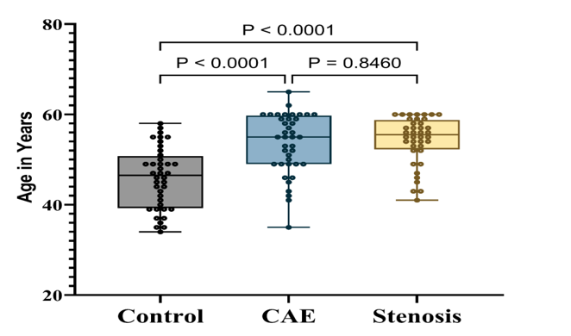
Figure 1: Distribution of age across the three study groups

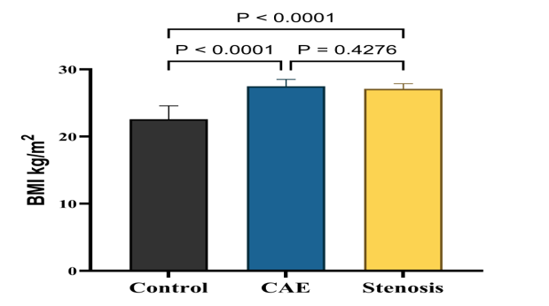
Figure 2: Body mass index across the three study groups

Lipid Profile Parameters (Table 2 and Figures 3 to 8)
Dyslipidaemia was pronounced in both patient groups relative to controls, though the pattern differed between CAE and stenosis in clinically meaningful ways. Table 2 presents the lipid parameters. Total cholesterol was substantially elevated in the CAE group (229.22 ± 45.52 mg/dL) and moderately elevated in the stenosis group (198.12 ± 46.48 mg/dL), compared to a control mean of 119.82 ± 13.48 mg/dL. The triglyceride picture was even more striking: the CAE group averaged 257.40 ± 67.98 mg/dL – nearly three times the control value – while stenosis patients had intermediate values (201.62 ± 58.81 mg/dL). Pairwise testing confirmed that even the CAE-versus-stenosis difference was significant (p = 0.001), suggesting a more severe metabolic derangement in ectasia.
HDL cholesterol moved in the opposite direction. Controls averaged 47.62 ± 3.50 mg/dL; in the CAE group, this dropped to 32.06 ± 4.96 mg/dL, with stenosis patients intermediate at 36.47 ± 6.69 mg/dL. All three pairwise comparisons were significant (p < 0.001). LDL cholesterol followed the pattern CAE > stenosis > control, with all pairwise differences achieving statistical significance. VLDL and non-HDL cholesterol similarly showed the highest values in the CAE group, followed by stenosis, then controls.

Table 2: Lipid profile parameters across the three study groups
Parameter (mg/dL) | Control (n=40) | CAE (n=40) | Stenosis (n=40) | H statistic | p-value
Total cholesterol | 119.82 ± 13.48 | 229.22 ± 45.52 | 198.12 ± 46.48 | 76.65 | <0.001*
Triglycerides | 93.63 ± 17.84 | 257.40 ± 67.98 | 201.62 ± 58.81 | 82.41 | <0.001*
HDL-C | 47.62 ± 3.50 | 32.06 ± 4.96 | 36.47 ± 6.69 | 70.23 | <0.001*
LDL-C | 90.46 ± 13.63 | 165.46 ± 33.21 | 129.50 ± 41.38 | 56.19 | <0.001*
VLDL | 18.73 ± 3.57 | 51.48 ± 13.60 | 40.32 ± 11.76 | 82.41 | <0.001*
Non-HDL-C | 72.21 ± 15.15 | 197.16 ± 47.01 | 161.65 ± 47.19 | 81.41 | <0.001*
*Data presented as mean ± SD. Kruskal–Wallis H test used. All pairwise comparisons (Control vs CAE, Control vs Stenosis, CAE vs Stenosis) were significant after Bonferroni correction (p < 0.05) for all parameters. *p < 0.05. HDL-C = high-density lipoprotein cholesterol; LDL-C = low-density lipoprotein cholesterol; VLDL = very low-density lipoprotein.*

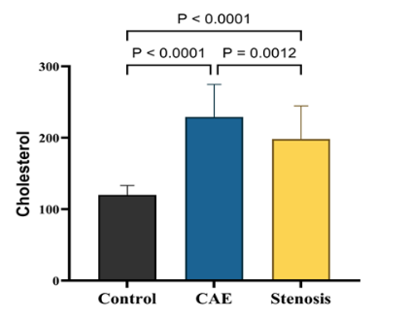
Figure 3: Total cholesterol levels across the three study groups

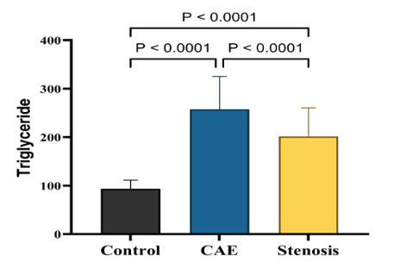
Figure 4: Serum triglyceride levels across the three study groups

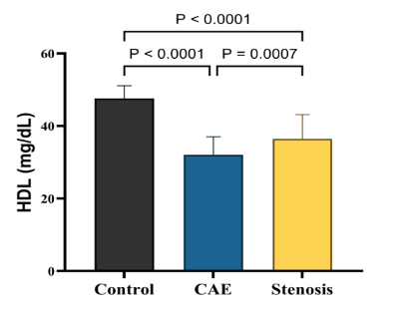
Figure 5: HDL cholesterol levels across the three study groups

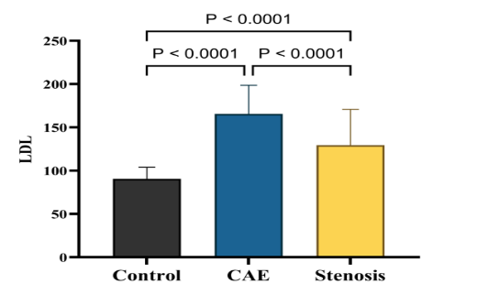
Figure 6: LDL cholesterol levels across the three study groups

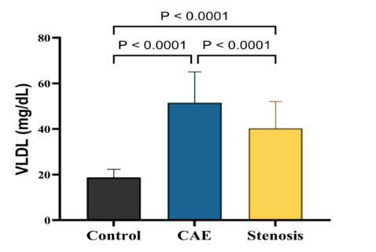
Figure 7: VLDL cholesterol levels across the three study groups

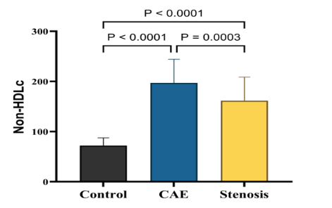

Figure 8: non-HDL cholesterol levels across the three study groups
Serum MMP-2 Levels
Table 3 and Figure 9 present serum MMP-2 concentrations. From a control mean of 15.01 ± 4.70 ng/mL, MMP-2 rose to 38.49 ± 4.40 ng/mL in stenosis and to 73.48 ± 7.65 ng/mL in CAE – a nearly five-fold increase over controls and roughly double the stenosis value. The overall model explained 94.7% of between-group variance (η² = 0.947). All pairwise comparisons were highly significant (p < 0.001), with effect sizes (r) exceeding 0.85 for control-versus-patient comparisons.

Table 3: Serum MMP-2 levels across the three study groups
Biomarker | Control (n=40) | CAE (n=40) | Stenosis (n=40) | H statistic | p-value
MMP-2 (ng/mL) | 15.01 ± 4.70 | 73.48 ± 7.65 | 38.49 ± 4.40 | 105.79 | <0.001*
*Data presented as mean ± SD. Kruskal–Wallis H test applied. All pairwise comparisons (Control vs CAE, Control vs Stenosis, CAE vs Stenosis) were significant after Bonferroni correction (p < 0.001 for all pairs). Effect sizes (r) exceeded 0.85 for control-vs-patient comparisons. *p < 0.05. MMP-2 = matrix metalloproteinase-2.*

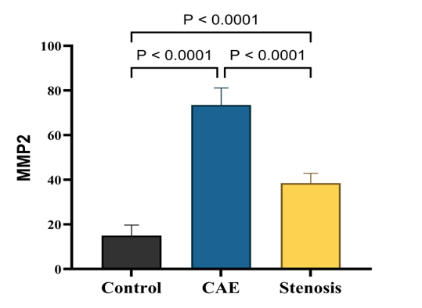
Figure 9: Serum MMP-2 levels across the three study groups

Haematological Inflammatory Indices (Table 4 and Figures 10 to 12)
Table 4 summarises the inflammatory indices. NLR was markedly elevated in CAE patients (6.38 ± 1.39) compared to both stenosis (2.92 ± 0.81) and control (1.89 ± 0.13) groups. PLR followed a similar hierarchy (CAE: 186.37 ± 12.76; stenosis: 149.02 ± 8.89; control: 103.41 ± 17.34), with all three groups well separated from one another and effect sizes exceeding 0.80 for every pairwise comparison. RDW was elevated in both patient groups (CAE: 47.45 ± 2.03%; stenosis: 45.73 ± 1.22%; control: 41.88 ± 1.79%). Although CAE still had the highest values, the degree of separation between CAE and stenosis was less pronounced (r = 0.526) compared to the other inflammatory indices.

Table 4: Haematological inflammatory indices across the three study groups
Parameter | Control (n=40) | CAE (n=40) | Stenosis (n=40) | H statistic | p-value
NLR | 1.89 ± 0.13 | 6.38 ± 1.39 | 2.92 ± 0.81 | 104.2 | <0.001*
PLR | 103.41 ± 17.34 | 186.37 ± 12.76 | 149.02 ± 8.89 | 100.93 | <0.001*
RDW (%) | 41.88 ± 1.79 | 47.45 ± 2.03 | 45.73 ± 1.22 | 79.07 | <0.001*
*Data presented as mean ± SD. Kruskal–Wallis H test applied. All pairwise comparisons were significant (p < 0.001) except where noted. *p < 0.05. NLR = neutrophil-to-lymphocyte ratio; PLR = platelet-to-lymphocyte ratio; RDW = red cell distribution width.*

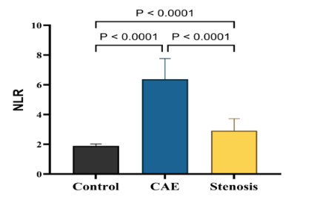
Figure 10: Neutrophil-to-lymphocyte ratio across the three study groups

(NLR box plot) shows the most dramatic elevation in CAE, with minimal overlap between groups – the CAE group’s NLR was approximately 3.4-fold higher than controls and 2.2-fold higher than the stenosis group.

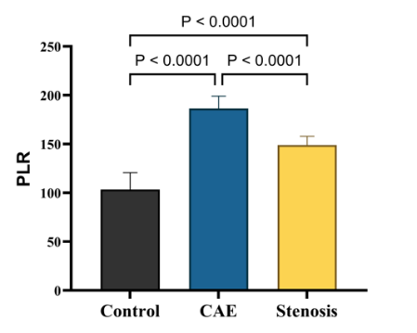
Figure 11: Platelet-to-lymphocyte ratio across the three study groups

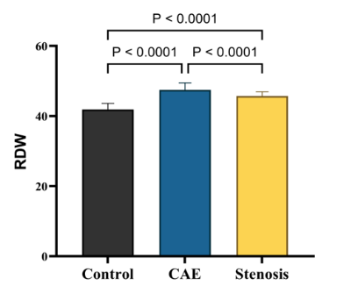
Figure 12: Red cell distribution width across the three study groups

Receiver Operating Characteristic Analysis
ROC curve analysis was performed for MMP-2 across the three pairwise comparisons, with results detailed in Table 5. MMP-2 achieved perfect discrimination (AUC = 1.000, 95% CI: 1.000–1.000) for CAE versus control, stenosis versus control, and CAE versus stenosis. The optimal cut-off value of >58.17 ng/mL distinguished CAE from both controls and stenosis with 100% sensitivity and 100% specificity. While these results are striking, we emphasise that the perfect AUC likely reflects the relatively small sample size and the absence of an independent validation cohort. In routine clinical practice, a biomarker would rarely achieve such perfect separation, and therefore these findings should be validated in larger, more diverse populations before clinical application.

Table 5: ROC analysis of serum MMP-2 for pairwise group discrimination
Comparison | AUC | SE | 95% CI | Cut-off (ng/mL) | Sens (%) | Spec (%) | PPV (%) | NPV (%) | +LR | –LR | Acc (%)
CAE vs Control | 1 | 0 | 1.000–1.000 | >58.17 | 100 | 100 | 100 | 100 | ∞ | 0 | 100
Stenosis vs Control | 1 | 0 | 1.000–1.000 | >32.17 | 100 | 100 | 100 | 100 | ∞ | 0 | 100
CAE vs Stenosis | 1 | 0 | 1.000–1.000 | >58.17 | 100 | 100 | 100 | 100 | ∞ | 0 | 100
*AUC = area under the receiver operating characteristic curve; SE = standard error; CI = confidence interval; Sens = sensitivity; Spec = specificity; PPV = positive predictive value; NPV = negative predictive value; +LR = positive likelihood ratio; –LR = negative likelihood ratio; Acc = classification accuracy. Cut-off values determined by Youden’s index. All p-values < 0.0001. ∞ denotes an undefined positive likelihood ratio (specificity = 100%, i.e., zero false positives).*

Correlation Analyses
Pearson correlation analyses were performed within each group to examine relationships between MMP-2, inflammatory indices, and lipid parameters. In the CAE group, MMP-2 showed a moderate positive correlation with NLR (r = 0.42, p = 0.007) and PLR (r = 0.38, p = 0.015), but no significant correlation with RDW (r = 0.19, p = 0.24). In the stenosis group, MMP-2 correlated weakly with NLR (r = 0.31, p = 0.05) and PLR (r = 0.28, p = 0.08). No significant correlations were observed between MMP-2 and any lipid parameter in either patient group (all p > 0.10).

Discussion
The present study provides compelling evidence that coronary artery ectasia represents a distinct, hyper-inflammatory, and excessive matrix-degrading phenotype of coronary artery disease, rather than merely a variant of typical atherosclerotic stenosis. Our findings demonstrate that while CAE and CAS share a nearly identical burden of traditional cardiovascular risk factors – including age, obesity, diabetes mellitus, hypertension, and smoking – they diverge profoundly in their biomarker profiles. Specifically, patients with CAE exhibited markedly elevated levels of MMP-2, more severe atherogenic dyslipidaemia, and significantly amplified systemic inflammatory indices (NLR, PLR, and RDW) compared to both patients with CAS and healthy controls.
The most striking finding of this study is the exceptional discriminative capacity of serum MMP-2. We observed a nearly five-fold elevation of MMP-2 in the CAE group compared to healthy controls, and roughly double the concentration seen in the CAS group. This substantial elevation aligns with the pathophysiological understanding of vascular remodelling. Matrix metalloproteinases, particularly MMP-2, are zinc-dependent endopeptidases crucial for the degradation of extracellular matrix components, including type IV collagen and elastin, which form the structural scaffold of the arterial media (16). Previous research has established that physiological and pathological vascular remodelling entails the degradation and reorganisation of this ECM scaffold (17). The hyperactivation of MMP-2 observed in our CAE cohort strongly supports the hypothesis that excessive proteolytic activity contributes directly to vessel wall thinning and progressive luminal dilation characteristic of ectatic disease, distinguishing it from the progressive intimal thickening and luminal narrowing seen in typical stenotic atherosclerosis (18). Furthermore, studies have shown that MMP-2 is upregulated in unstable coronary artery disease and overexpressed on the platelet surface in CAD patients, highlighting its role in plaque vulnerability and adverse remodelling (19). The perfect discrimination (AUC = 1.000) achieved by MMP-2 in differentiating CAE from CAS in our study underscores its potential as a robust diagnostic biomarker, although this finding requires validation in larger independent cohorts.
In parallel with ECM degradation, our study highlights the central role of systemic inflammation in the pathogenesis of CAE. The haematological inflammatory indices – NLR, PLR, and RDW – were all significantly elevated in the CAE group compared to the CAS and control groups. The disproportionate elevation of NLR (more than three-fold higher than controls and 2.2-fold higher than CAS) indicates a pronounced neutrophil-dominant inflammatory milieu in ectatic disease. Neutrophils are primary sources of proteolytic enzymes, including various MMPs and elastases; thus, this innate immune overactivation likely synergises with MMP-2 to accelerate matrix destruction (20). This observation is consistent with previous literature identifying NLR as an independent predictor of CAD severity, plaque vulnerability, and adverse cardiovascular outcomes (21, 22). Similarly, the marked elevation of PLR in the CAE group reflects an intensified thrombo-inflammatory state. PLR is an integrated reflection of pro-thrombotic and inflammatory pathways, and its elevation has been associated with increased cardiovascular mortality and the complexity of coronary lesions (23).
Furthermore, the significant elevation of RDW in both patient groups, with the highest values in the CAE cohort, provides additional insight into the systemic metabolic and oxidative stress associated with these conditions. RDW, a measure of erythrocyte size heterogeneity, has emerged as a powerful prognostic indicator in cardiovascular disease, reflecting chronic inflammatory and oxidative insults that affect erythropoiesis and red blood cell survival (24). Elevated RDW is independently associated with endothelial dysfunction, membrane lipid peroxidation, and systemic inflammation (25). The elevated RDW in our CAE patients further corroborates the presence of a severe, chronic inflammatory and oxidative burden that likely exacerbates endothelial injury and maladaptive vascular remodelling.
Our lipid profile analysis further differentiates the metabolic derangements in CAE from those in CAS. The CAE group exhibited the most severe atherogenic dyslipidaemia, characterised by the highest levels of total cholesterol, triglycerides, LDL-C, VLDL, and non-HDL-C, alongside the lowest levels of HDL-C. This pronounced dyslipidaemia, particularly the nearly three-fold increase in triglycerides and the significant reduction in HDL-C, suggests a more severe impairment of lipid metabolism and reverse cholesterol transport in ectatic disease. Elevated triglycerides and LDL-C, combined with low HDL-C, are established drivers of endothelial injury, foam cell formation, and oxidative stress (26). Recent evidence indicates that disorders in lipid metabolism, including elevated remnant cholesterol and specific lipoprotein abnormalities, are closely associated with the pathogenesis of CAE (27). The severe dyslipidaemia observed in our CAE cohort likely acts as a persistent inflammatory stimulus, perpetuating endothelial dysfunction and fuelling the continuous activation of MMPs and innate immune cells, thereby driving the vicious cycle of vascular wall degradation and dilation.
Interestingly, the near-identical prevalence of conventional cardiovascular risk factors (diabetes, hypertension, smoking) between the CAE and CAS groups suggests that these factors alone are insufficient to dictate the specific trajectory of vascular remodelling – dilation versus narrowing. Instead, it appears that the convergence of severe atherogenic dyslipidaemia, amplified systemic inflammation, and hyperactive matrix degradation – as evidenced by elevated MMP-2, NLR, PLR, and RDW – creates a specific pathological microenvironment that favours excessive vessel dilation.

Study Limitations and Future Directions
Several limitations of this study should be acknowledged. First, the cross-sectional design precludes the establishment of causal relationships between the measured biomarkers and the development of CAE. Longitudinal studies are required to determine whether elevated MMP-2 and inflammatory indices precede the onset of ectasia or are consequences of the disease process. Second, the sample size, while sufficient to detect highly significant differences with large effect sizes, is relatively small (40 participants per group) and drawn from a single geographic region (Iraq), which may limit the generalisability of the findings to other populations. Third, we measured circulating systemic levels of MMP-2 and inflammatory markers, which may not perfectly reflect the localised tissue concentrations within the coronary arterial wall. The perfect discrimination (AUC = 1.000) observed for MMP-2, while statistically impressive, is biologically implausible in a real-world clinical setting and likely reflects the limited sample size, lack of an independent validation cohort, and potential overfitting. Therefore, these diagnostic accuracy estimates should be interpreted with caution, and validation in larger, multi-centre studies is essential before any clinical application.
Fourth, the control group consisted of individuals with zero prevalence of diabetes, hypertension, and smoking, which does not represent a typical general population. This selection bias may have artificially inflated the observed differences between patient groups and controls. Future studies should recruit control participants with age- and risk-factor-matched characteristics to provide more realistic comparisons. Fifth, we did not perform intravascular imaging (such as optical coherence tomography or intravascular ultrasound) or local biomarker sampling from coronary vessels, which could provide deeper mechanistic insights into the tissue-specific expression of MMP-2 and inflammatory mediators.
Future research directions should include prospective cohort studies with serial biomarker measurements to establish temporal relationships, multi-centre validation of the optimal MMP-2 cut-off values, integration of genetic polymorphisms (such as MMP-2 gene variants) to assess susceptibility to CAE, and exploration of potential therapeutic strategies targeting MMP-2 or inflammatory pathways to prevent or slow the progression of coronary ectasia. Additionally, studies comparing CAE patients with and without concurrent stenosis would help elucidate whether mixed phenotypes represent a distinct pathophysiological entity.

Conclusion
In conclusion, the substantial elevation of MMP-2, combined with severe atherogenic dyslipidaemia and amplified systemic inflammatory indices (NLR, PLR, RDW), indicates that distinct, excessive proteolytic and inflammatory pathways drive the pathological vascular dilation in coronary artery ectasia. These findings not only enhance our understanding of the divergent pathogenetic mechanisms underlying ectatic versus stenotic coronary disease but also highlight MMP-2 and routine haematological indices as robust, accessible biomarkers for improved risk stratification and phenotypic discrimination in patients with coronary artery disease. Validation of these findings in larger, independent cohorts is warranted before clinical implementation.

List of Abbreviations
ACS: Acute coronary syndrome
AUC: Area under the curve
BMI: Body mass index
CAD: Coronary artery disease
CAE: Coronary artery ectasia
CAS: Coronary artery stenosis
CBC: Complete blood count
CI: Confidence interval
DM: Diabetes mellitus
ECM: Extracellular matrix
EF: Ejection fraction
ELISA: Enzyme-linked immunosorbent assay
HDL C: High-density lipoprotein cholesterol
LDL C: Low-density lipoprotein cholesterol
–LR: Negative likelihood ratio
+LR: Positive likelihood ratio
MMP 2: Matrix metalloproteinase 2
MMPs: Matrix metalloproteinases
NLR: Neutrophil to lymphocyte ratio
Non-HDL: Non-high-density lipoprotein cholesterol
NPV: Negative predictive value
PLR: Platelet to lymphocyte ratio
PPV: Positive predictive value
RDW: Red cell distribution width
ROC: Receiver operating characteristic
SE: Standard error
Sens: Sensitivity
Spec: Specificity
TC: Total cholesterol
TG: Triglycerides
VLDL: Very low-density lipoprotein

Declarations
Ethics Approval and Consent to Participate
This study was conducted in accordance with the principles of the Declaration of Helsinki. Ethical approval was obtained from the Institutional Review Board of Al-Nahrain University College of Medicine (Approval No. 2024/CS/89, dated 15 October 2024). Written informed consent was obtained from all participants before enrolment. Participants were informed of their right to withdraw from the study at any time without consequence.

Consent for Publication
All authors gave their consent for the publication of this work under the Creative Commons Attribution Non-Commercial 4.0 license.

Data Availability
The datasets generated and analysed during the current study are available from the corresponding author on reasonable request, subject to institutional data sharing policies and participant confidentiality protections.

Competing Interests
The authors declare that they have no competing interests. No financial or personal relationships with other people or organisations have inappropriately influenced this work.

Funding
This research received no specific grant from any funding agency in the public, commercial, or not-for-profit sectors. The study was conducted as part of the academic requirements of the MSc programme at Al-Nahrain University, with all costs borne by the authors.

Author Contributions
JNI worked on the conceptualisation, investigation, data curation, formal analysis, writing the original draft, writing of the review & editing, and project administration.
ARJ worked on the methodology, validation, supervision, formal analysis, writing of the review & editing.
AAS worked on conceptualisation, methodology, resources, supervision, writing of the review & editing and funding acquisition (none).

Acknowledgements
The authors sincerely thank the staff of the Clinical Biochemistry Laboratory at Al-Imamain Al-Kadhimain Medical City, the catheterisation laboratory team at Ibn Al-Bitar Centre for Cardiac Surgery, and the nursing staff at Baqubah Teaching Hospital for their invaluable assistance with participant recruitment, sample collection, and logistical support. We also extend our gratitude to all study participants for their cooperation and willingness to contribute to medical research.

References
- Bararu-Bojan I, Badulescu OV, Badescu MC, Vladeanu MC, Plesoianu CE, Bojan A, Iliescu-Halitchi D, Tudor R, Huzum B, Frasinariua OE, Ciocoiu M. New insights into the pathophysiology of coronary artery aneurysms. Diagnostics. 2024 Sep 29;14(19):2167. https://doi.org/10.3390/diagnostics14192167
- Raheem JK, Mohialdeen DM, Hassan KW. The Prevalence, Prediction and Angiographic Characteristics of Coronary Ectasia in Slemani Cardiac Center. Thi-Qar Medical Journal. 2023 Dec 31;26(2):681-92.
- Richards GH, Hong KL, Henein MY, Hanratty C, Boles U. Coronary artery ectasia: review of the non-atherosclerotic molecular and pathophysiologic concepts. International Journal of Molecular Sciences. 2022 May 6;23(9):5195. https://doi.org/10.3390/ijms23095195
- Mir MA, Dar MA, Qadir A. Exploring the landscape of coronary artery disease: a comprehensive review. Am. J. Biomed. Pharm. 2024 Apr;1:9-22.
- Antoniadis AP, Chatzizisis YS, Giannoglou GD. Pathogenetic mechanisms of coronary ectasia. International Journal of Cardiology. 2008 Nov 28;130(3):335-43. https://doi.org/10.1016/j.ijcard.2008.05.071
- Shao C, Wang J, Tian J, Tang YD. Coronary artery disease: from mechanism to clinical practice. Coronary Artery Disease: Therapeutics and Drug Discovery. 2020 Mar 26:1-36. https://doi.org/10.1007/978-981-15-2517-9_1
- Zhang L, Zhou J, Kong W. Extracellular matrix in vascular homeostasis and disease. Nature Reviews Cardiology. 2025 May;22(5):333-53. https://doi.org/10.1038/s41569-024-01103-0
- Wolosowicz M, Prokopiuk S, Kaminski TW. The complex role of matrix metalloproteinase-2 (MMP-2) in health and disease. International Journal of Molecular Sciences. 2024 Dec 21;25(24):13691. https://doi.org/10.3390/ijms252413691
- Tangjitgamol S, Udayachalerm W, Wanishsawad C, Kaewwanna W, Ativanichayapong N. Association of neutrophil-to-lymphocyte ratio and platelet-to-lymphocyte ratio and coronary artery disease among the physicians. Journal of Inflammation Research. 2024 Dec 31:59-66. https://doi.org/10.2147/JIR.S447750
- Islam MM, Satici MO, Eroglu SE. Unraveling the clinical significance and prognostic value of the neutrophil-to-lymphocyte ratio, platelet-to-lymphocyte ratio, systemic immune-inflammation index, systemic inflammation response index, and delta neutrophil index: An extensive literature review. Turkish Journal of Emergency Medicine. 2024 Jan 1;24(1):8-19. https://doi.org/10.4103/tjem.tjem_198_23
- Ji X, Ke W. Red blood cell distribution width and all-cause mortality in congestive heart failure patients: a retrospective cohort study based on the Mimic-III database. Frontiers in Cardiovascular Medicine. 2023 May 3;10:1126718. https://doi.org/10.3389/fcvm.2023.1126718
- Afzal M. Red Cell Distribution Width (RDW) as a Prognostic Marker in Systemic Diseases: A Mini Review. Indian Journal of Hematology and Blood Transfusion. 2025 Nov 6:1-7. https://doi.org/10.1007/s12288-025-02210-9
- Madaudo C, Bono G, Ortello A, Astuti G, Mingoia G, Galassi AR, Sucato V. Dysfunctional high-density lipoprotein cholesterol and coronary artery disease: a narrative review. Journal of Personalized Medicine. 2024 Sep 19;14(9):996. https://doi.org/10.3390/jpm14090996
- Dimitriadis K, Theofilis P, Iliakis P, Pyrpyris N, Dri E, Sakalidis A, Soulaidopoulos S, Tsioufis P, Fragkoulis C, Chrysohoou C, Tsiachris D. Management of dyslipidemia in coronary artery disease: the present and the future. Coronary Artery Disease. 2024 Sep 1;35(6):516-24. https://doi.org/10.1097/MCA.0000000000001375
- Ojo O, Oguntola BO, Odele RO, Nnaji FC, Ojogbane F. Clinical Characteristics, Risk Factors and Angiographic Profile of Patients with suspected coronary artery disease Undergoing Coronary Angiography in Ekiti, South-West, Nigeria. Babcock University Medical Journal. 2025 Jun 30;8(1):46-52. https://doi.org/10.38029/babcockuniv.med.j..v8i1.597
- Wang X, Berry E, Hernandez-Anzaldo S, Takawale A, Kassiri Z, Fernandez-Patron C. Matrix Metalloproteinase-2 Mediates a Mechanism of Metabolic Cardioprotection Consisting of Negative Regulation of the Sterol Regulatory Element–Binding Protein-2/3-Hydroxy-3-Methylglutaryl-CoA Reductase Pathway in the Heart. Hypertension. 2015 Apr;65(4):882-8. https://doi.org/10.1161/HYPERTENSIONAHA.114.04989
- Galis ZS, Khatri JJ. Matrix metalloproteinases in vascular remodeling and atherogenesis: the good, the bad, and the ugly. Circulation Research. 2002 Feb 22;90(3):251-62. https://doi.org/10.1161/res.90.3.251
- Antoniadis AP, Chatzizisis YS, Giannoglou GD. Pathogenetic mechanisms of coronary ectasia. International Journal of Cardiology. 2008 Nov 28;130(3):335-43. https://doi.org/10.1016/j.ijcard.2008.05.071
- Samah N, Ugusman A, Hamid AA, Sulaiman N, Aminuddin A. Role of Matrix Metalloproteinase‐2 in the Development of Atherosclerosis among Patients with Coronary Artery Disease. Mediators of Inflammation. 2023;2023(1):9715114. https://doi.org/10.1155/2023/9715114
- Vrachatis DA, Papathanasiou KA, Kazantzis D, Sanz-Sánchez J, Giotaki SG, Raisakis K, Kaoukis A, Kossyvakis C, Deftereos G, Reimers B, Avramides D. Inflammatory biomarkers in coronary artery ectasia: a systematic review and meta-analysis. Diagnostics. 2022 Apr 19;12(5):1026. https://doi.org/10.3390/diagnostics12051026
- Kaya H, Ertaş F, İslamoğlu Y, Kaya Z, Atılgan ZA, Çil H, Çalışkan A, Aydın M, Oylumlu M, Soydinç MS. Association between neutrophil to lymphocyte ratio and severity of coronary artery disease. Clinical and Applied Thrombosis/Hemostasis. 2014 Jan;20(1):50-4. https://doi.org/10.1177/1076029612452116
- Arbel Y, Finkelstein A, Halkin A, Birati EY, Revivo M, Zuzut M, Shevach A, Berliner S, Herz I, Keren G, Banai S. Neutrophil/lymphocyte ratio is related to the severity of coronary artery disease and clinical outcome in patients undergoing angiography. Atherosclerosis. 2012 Dec 1;225(2):456-60. https://doi.org/10.1016/j.atherosclerosis.2012.09.009
- Kurtul A, Ornek E. Platelet to lymphocyte ratio in cardiovascular diseases: a systematic review. Angiology. 2019 Oct;70(9):802-18. https://doi.org/10.1177/0003319719845186
- Danese E, Lippi G, Montagnana M. Red blood cell distribution width and cardiovascular diseases. Journal of Thoracic Disease. 2015 Oct;7(10):E402.
- Namazi G, Beygi SH, Vahidi MH, Asa P, Bahmani F, Mafi A, Raygan F. Relationship between red cell distribution width and oxidative stress indexes in patients with coronary artery disease. Reports of Biochemistry & Molecular Biology. 2023 Jul;12(2):241. https://doi.org/10.61186/rbmb.12.2.241
- Jiang L, Wei W, Kang S, Li XL, Luo Y. Insights into lipid metabolism and immune-inflammatory responses in the pathogenesis of coronary artery ectasia. Frontiers in Physiology. 2023 Jan 25;14:1096991. https://doi.org/10.3389/fphys.2023.1096991
- Ozturk S, Yetkin E, Waltenberger J. Molecular and cellular insights into the pathogenesis of coronary artery ectasia. Cardiovascular Pathology. 2018 Jul 1;35:37-47. https://doi.org/10.1016/j.carpath.2018.04.005

